|  |  |  |  |
| --- | --- | --- | --- |
| **Date:** | **18/07/2020** | **Name:** | **Chesmi B R** |
| **Course:** | **Computer Vision Basic** | **USN:** | **4AL16EC100** |
| **Topic:** | **Final exam** | **Semester & Section:** | **8th – A** |
| **GitHub Repository:** | **chesmibr** |  |  |

**CERTIFICATE**

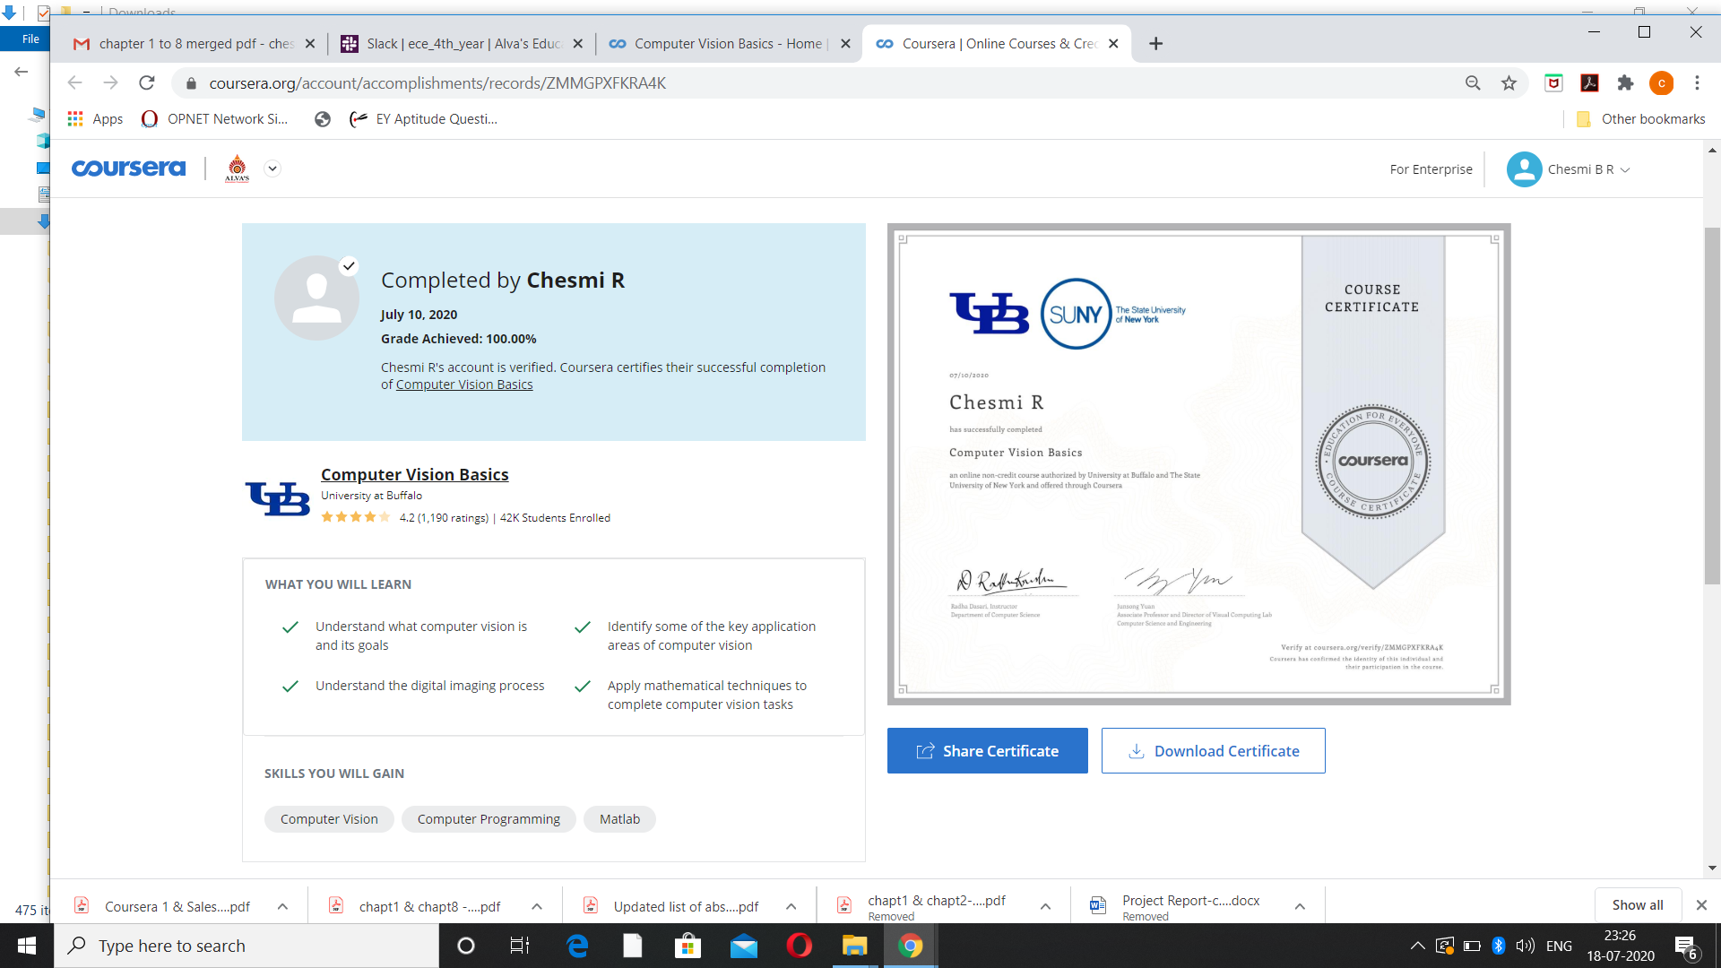

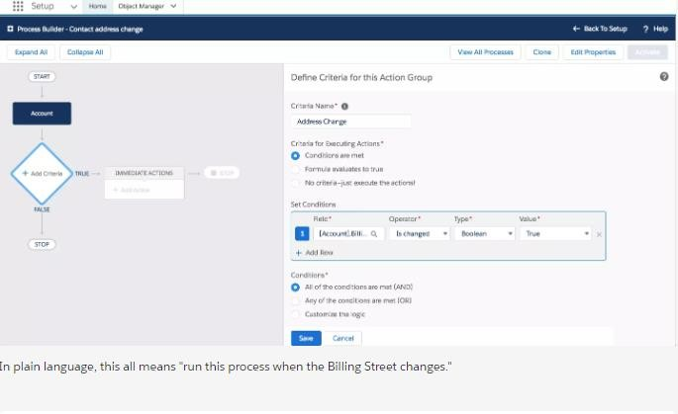

|  |  |  |  |
| --- | --- | --- | --- |
| **Date:** | **18/07/2020** | **Name:** | **Chesmi B R** |
| **Course:** | **Salesforce Developer** | **USN:** | **4AL16EC100** |
| **Topic:** | **Process Builder** | **Semester & Section:** | **8th – A** |
| **GitHub Repository:** | **Chesmibr** |  |  |

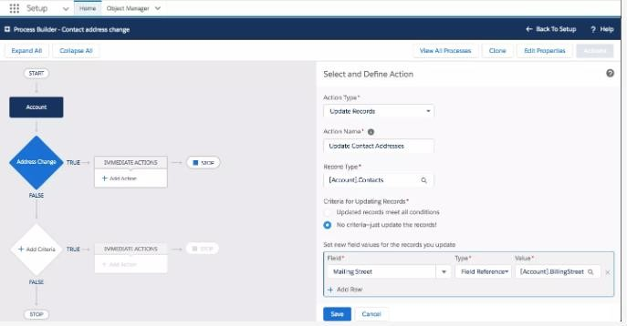

**AFTERNOON SESSION DETAILS**

**Image of Session**

**REPORT –**

Process Builder is a workflow tool that helps automate business processes without writing a single line of code. For example, imagine that a company you do business with (which we call an Account in Salesforce), changes its location. You'd want a way to automatically update the business address of all the people that work at that company (your Contacts)

# Create a New Process on the Account Object

Gear icon to access Setup in Lightning ExperienceCreate a process and then select the object on which the process runs. Click and select **Setup**. This launches Setup in a new tab.

1. From Setup, enter Builder in the Quick Find box, and select **Process Builder**.
2. Click **New**.
3. For Process Name, type Contact address change.
4. For The process starts when, select **A record changes**, and click **Save**.
5. Click **+ Add Object**.
6. In the right window, select **Account** from the Object drop-down list.

# For Start the process select when a record is created or edited.

1. Click **Save**.

# Create Criteria

You now define the criteria that determine when this process runs.

1. Click Add Criteria.
2. For Criteria Name, type Address Change.
3. For Criteria for Executing Actions, keep it set to Conditions are met.
4. For Set Filter Conditions, click Find a field..., select Billing Street and click Choose.
5. Set Operator to Is Changed, and set Value to True.
6. For Conditions, keep it set to All of the conditions are met (AND).
7. Click Save.

# Create an Action

In this step you define what happens when the Billing Street changes.

1. Under the Immediate Actions box, click **+ Add Action**.
2. In the Action Type drop-down list, select **Update Records**.
3. For Action Name, type Update Contact Addresses.
4. For Record Type, click the radio button next to **Select a record related to the Account**, then scroll down and select **Contacts**, and click **Choose**. This is pretty powerful stuff, so pause and take note. Process Builder allows you to choose not just fields on Accounts, but fields that are related to Accounts.
5. For **Criteria for Updating Records**, keep it set at **No criteria—just update the records!**.
6. Under **Set new field values for the records you update**, click **Find a field...**, and then scroll down and select **Mailing Street**.
7. Select **Field Reference** for the **Type**.
8. For **Value**, select **Billing Street** as the Account field and click **Choose**.
9. Click **Save**.
10. Click **Activate** and then click **Confirm**.

# Check the Process

If everything works correctly, whenever an account has a change of address, the address change is made for everyone who works for that company. Let’s test that.

1. App Launcher iconClick to open the App Launcher. Select **Contacts**.
2. Click **Recently Viewed** and select the **All Contacts** list, then click **Tim Barr**.
3. On Tim Barr’s contact record, click **Details**.
4. On Tim Barr’s detail page, note the mailing address [1] and account name [2].
5. Click the account name, Grand Hotels & Resorts Ltd. This opens the account for Grand Hotels & Resorts Ltd.
6. On the Grand Hotels & Resorts Ltd. account record, click Details.
7. Click Edit.
8. Change the billing street address and click Save.
9. Click Related.
10. Scroll down to Contacts and click Tim Barr. Click Details. On his detail page, notice that his mailing address has been updated.